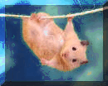 Note on the software

NATURE OF THE SOFTWARE :
The Centre d'Informations (CI) aim is to articulate and display whatever type of knowledge available on a given field such as, here, the study of small rodent hosts and their parasites bio-ecology.  The software is built as a network of information articulated using concepts (figure). The website should not be understood as a conventional search engine but as different ways to navigate within this knowledge (information and concept) network.  Each information is thoroughly formalized; the aim is not exhaustivity or information amount but rather information quality so as to ensure the best possible articulation within the existing network (quality of the network) and ensure the subject diversity so as to cover the field with robustness. | 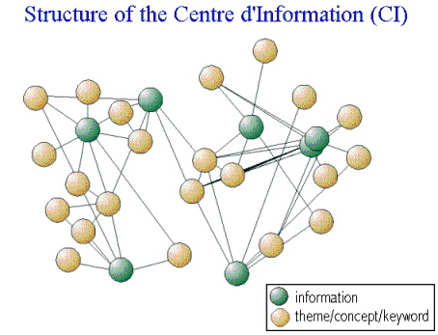  Navigation in the website : the user can move from one information to another by taking any "path". Various tables of contents facilitate navigation.
 | concept : Jean Le Fur, 1999
NAVIGATION IN THE CI
- Select an entry which seems (even partly) appropriate for you and then navigate until you can display an information.
- You can thereafter navigate from one information to the other using the associated concepts (links in blue) at the bottom of the page.
- if a click on a link does not produce any change, this is because the only information about the requested theme is the one currently displayed.
- To go back, use the "backward" button of your browser.
INFORMATION DISPLAY
- Each information is displayed following the same pattern:
  - Title (and details subtitle)
  - Summary: A small text describing the information aim and/or content (according to the proposing author point of the view)
  - The illustrations or media which constitute the actual information. they are formalized as clickable buttons corresponding to their type.
The illustrations can be of many types as you will see (see the corresponding table of content).
A click on the button displays the information within the frame, a click on the side word (describing the type of support) opens it in a new window. For displaying an illustration of type web page, it is advisable to click on the word "web page".
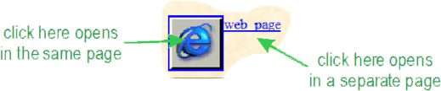
  - The associated keywords
  - The corresponding navigation items - these links adress you the set of keywords of the corresponding type and give you access to related information.
  - The information context (source, date, author, type, etc.).
  - A navigation suggestion is proposed based on the most covered path of previous users (number of times this trail has been covered)
  - At the bottom of the page clickable buttons with links to the main crossroads of the SimMasto website.
BACK TO HOME PAGES
This is the back to Centre d'Information (CI) home page button. It should be always accessible.

Created 14 january 2003, modified 27.10.09 by jlefur

